Questions on Matrices

1. Let’s create a 3x3 matrix with data - 1,2,3,4,5,6,7,8,9

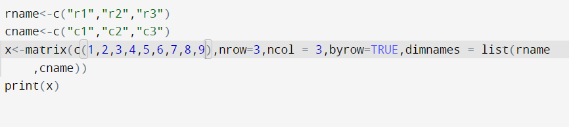

Output:

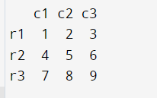

1. create a 2x3 matrix with data 1,2,3,4,5,6 using vector

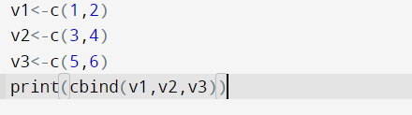

Output:

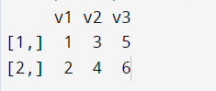

1. . create a 3x3 matrix with values - 1,2,3,4,5,6,7,8,9 and add a new row and new column

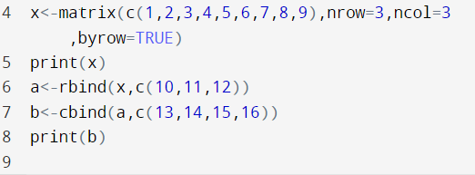

Ouput:

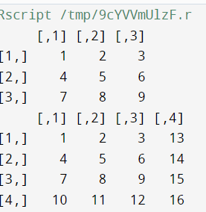

1. create a 2x3 matrix with rows and columns names as ‘row1’, ‘row2’ and ‘col1’, ‘col2’, ‘col3’ respectively.

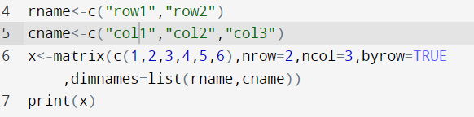

Output:

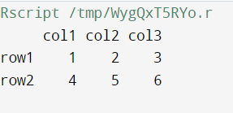

1. Create a 4\*4 matrix and access the first 2 rows and 3 column matrix

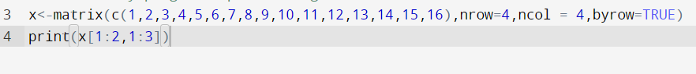

Output:

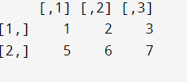

1. Create a 4\*4 matrix and access the first 2 row and 3 column element



Output:

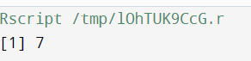

1. Create 2 matrices and perform the sum, sub, divide and product

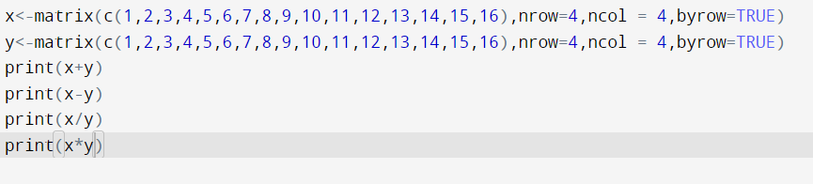

Output:

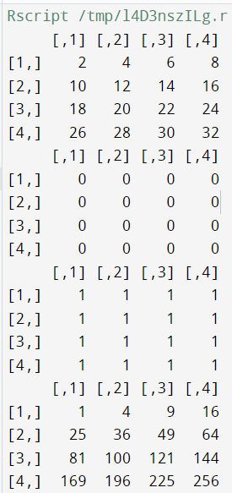

1. Create 5\*6 matrix and delete 2 rows and 3 columns from the matrix.

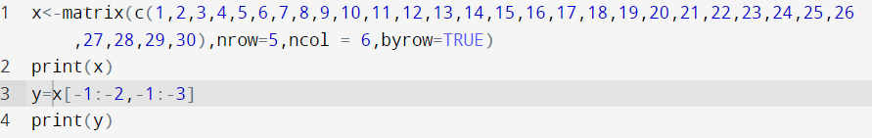

Output:

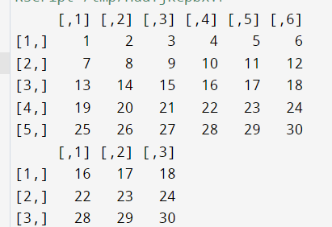

1. . Create a 3\*5 matrix having all values less than 50 and then replace all the values greater than 25 with zero and less than 25 with 1 and 25 with “a”.

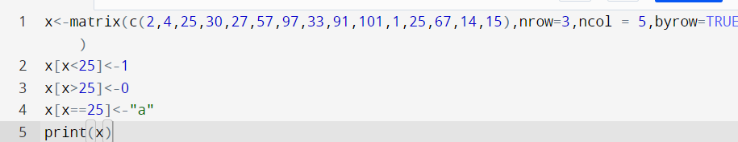

Output:

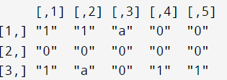

1. 10.Create 4\*4 diagonal matrix having diagonal elements at 2,4,6,8.

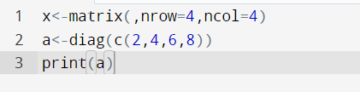

Output:

